**Test Case 4**

In Home menu, if a save file is exists in the same directory, type “C”.

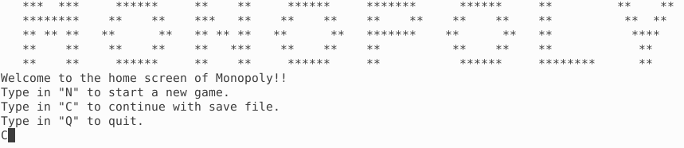

By default, input “Save5”.

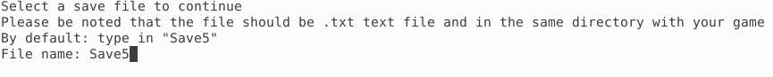

This message pop out.

